**Data Representation**

**Data Representation: Numeric Conversions**

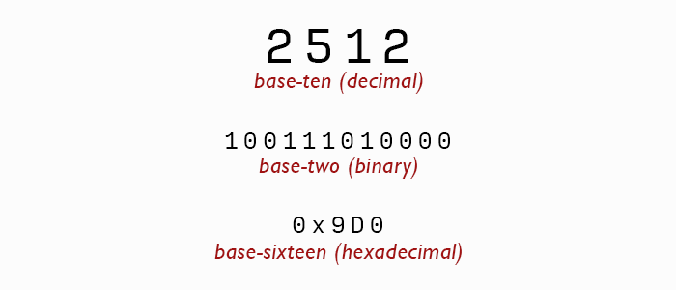

Base ten system is what we learned to count on our fingers and toes at a young age. Also known as the decimal system, it uses the decimal point to separate whole numbers from decimal fractions. The base ten system consisting of 10 digits to show all numbers 0,1,2,3,4,5,6,7,8,9 using place value.

Binary, the prefix gives you a hint of a two coefficient. Utilizes only the numbers “0 and 1”. These are the recognized digits for computers O = off and 1 = on. The value of each place is twice the value of the previous place. (ex* 2, 4, 8, 16, 32, 64, 128) To evaluate a binary number’s decimal equivalent, multiply each number by its place value and add all the results together.

Hexadecimal is a simpler way for human operators to utilize binary.  A single place value in hexadecimal represents four bits of memory. When you double that two places represents eight bits, or one byte. Hence, you’ll see hexadecimal used to represent the value of memory registers. The bit sizing makes it easier to read than a string of ones and zeros.